**Summary Test Results**

**Attempt 1  
Baseline test - 1vuser**  
1000 posts, duration 1 min, cpu count 8

Average Throughput 8175 req/sec

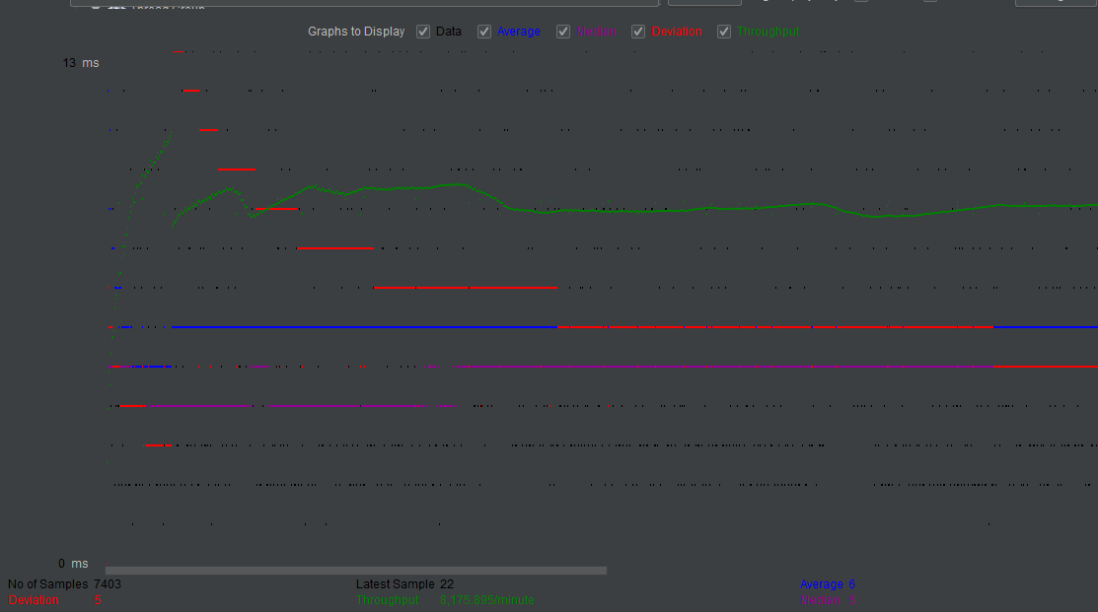

**Attempt 2**

**Fixed load by saturation point**

10vusers, rump up 10

1000 posts, duration 3 min, cpu count 8

Average Throughput 4393 req/sec

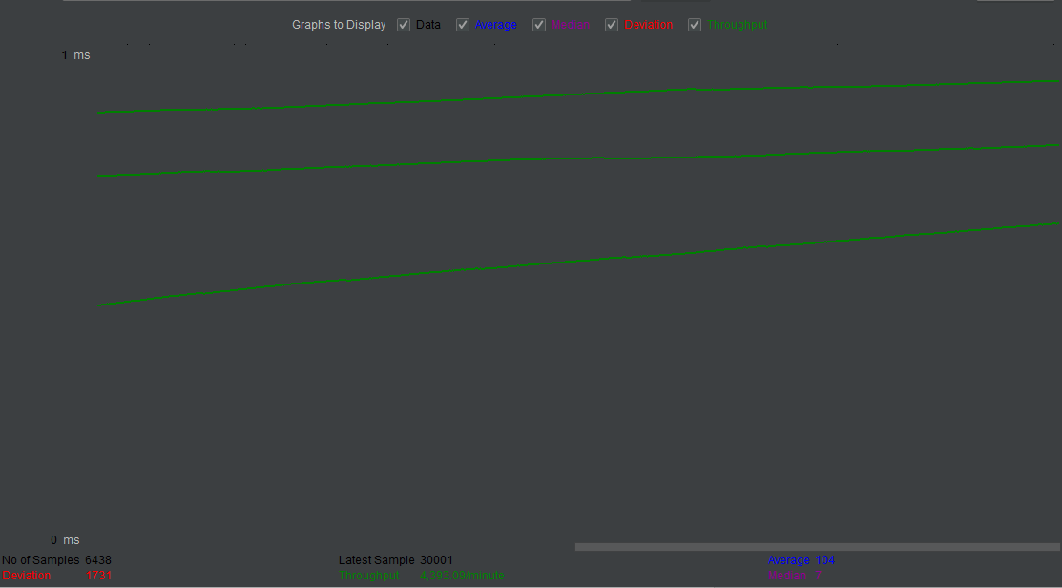

Attempt 3

